# PowerManagementSystem

The PowerManagementSystem (PMS) will be in charge of providing energy to all components of the Water Quality Monitoring device (Rastaban). The device has the following components that require power:

# Power Supply

This table is just an indication of the possible power consumption and it was made to give some insights. After seeing this table I think I can conclude that a 24V 10A (240W) power supply should be sufficient to run the whole device at full power, something that will not be typical but should be accounted for. This power supply will be an external one for the time being, since it eliminates the need for a much bigger PCB and extra EMC and safety precautions. It also gives us the possibility to easily swap the PSU out if it gets damaged.

# Preventing Noise

It is important to prevent noise that may be caused by some more power hungry components in the device. That’s the reason why I will try create power lines for 12V, 9V, 5.2V and possibly 3.3V. The 12V rail will use a lot of power where the 5.2 and 3.3 are on the lower side of power usage. The use of capacitors will also smooth out the voltage dips that may occur while load becomes high.

# Planes on PCB

There are multiple benefits to using ground planes, something that is already widely known. It improves thermals for heat inducing chips and it helps preventing EMC issues. It may however be wise to keep analog and digital grounds separated, to prevent ground loops and the noise it creates. We may use positive 12V or 5.2V planes as well, so we can transfer high currents to some loads without heating up the PCB, but this may introduce interference (EMC) with signal lines, something that is not tolerable.

# EMC

EMC or electromagnetic compatibility is a significant part of every PCB design. This starts at the schematic level by making sure there are enough decoupling capacitors, 0 ohm star grounding and keeping HIGH power LOW power, digital and analog circuits as isolated as possible.

# ESD protection

A typical voltage clamping diode circuit is shown below. The main responsibility of this voltage clamping circuit is to limit the accumulation of voltages on the input terminal of the buffer. Note that this could also be applied to the differential input on an op-amp. The operation of this circuit is very simple and, under normal conditions, diodes D1 and D2 are reverse biased. Whenever the voltage at the input is larger than the supply rail voltage, then diode D1 is forward biased and conducts. Similarly, when the voltage at the input falls below ground, then diode D2 is forward biased and conducts from the ground towards the input. This circuit seems to be suitable for at least the i2c data lines in our design.

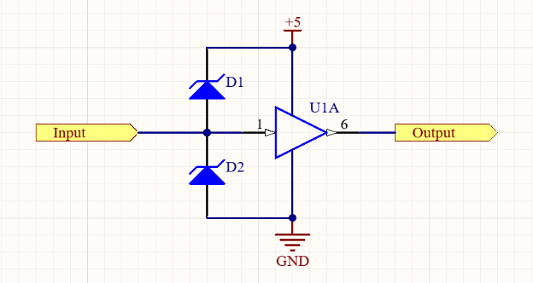

# Power regulators

There a 2 main types of upping or lowering the voltage in a circuit. We can use Buck/Boost converters or linear regulators. The main benefit of using a buck/boost converter is its high efficiency and therefor lower heat dissipation. Sadly it comes at the price of many components (PCB space) and a noise on the supply line due to switching. A linear regulator on the other hand wastes an extreme amount of the energy supplied to it as heat, but the output voltage does not create as much noise. A great bonus is that if the voltage difference is not great between input and output, than sometimes the linear regulator is more efficient than a switching.

Choosing what type fits our voltage rails really depends on what is more important in our device’s case. We care more about functionality and repairability at this stage of the device so using a linear regulator would most likely be sufficient in most of our cases.

# 12V vs 24V

Since the primary and secondary stepper motors are designed to run on 12V we think it may be wise to choose a 12V supply. 24V gives us more headroom for voltage dips, but the motors can probably not handle the voltage difference. It is also less efficient to buck a higher voltage to a lower voltage, so keeping the difference lower is better. We do need to compensate for the possible voltage dips with capacitors and a PSU with a rather high current (probably 10A). I think that a 120W power supply would suffice for this prototype.

# Tracewith

